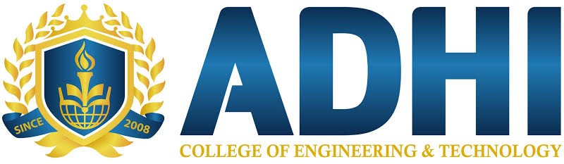

INDUSTRIAL VISIT TO TVS Training and Services Ltd (TTC-1)
The third year students of ECE Department visited the TVS Training and Services Ltd (TTC-1) on 27th Feb 2020 and 28th Feb 2020, Ms.Banumathy V, Mrs. Saranya and Ms. Priya had coordinated the industrial visit with 78 students. We like to extend our sincere thanks to our management for giving this great opportunity to visit TVS Training and Services Ltd (TTC-1), Ambattur Industrial Estate, Chennai.
INDUSTRY PROFILE:
TVS Training and Services Ltd is a TVS group company that was established in 2011, in Chennai. TVS TS provides training in a variety of domains from automotive and engineering to finance and retail. It provides training and assured employment to unemployed youth across the country. TVSTS has 5 state-of-the-art technical training centers, 4 in Chennai and one in Sri city. The centers combined have over 30 class rooms, 20 labs/workshops with state-of-the- art equipment for engineering/manufacturing training.
RESPONSIBILITIES
- Provide customized training programs to industrial personnel from various companies.
- Provide domain specific knowledge, skill and social competencies
- Offer courses at introductory and advanced levels.
TOPICS DISCUSSED:

1. Industrial Manufacturing and Automation

2. Embedded Systems
STUDENTS FEEDBACK:
TVSTS was a great experience to learn new things. We learnt many things and got good exposure. It provides an opportunity to learn practically through interaction, working methods and employment practices.

